IDEATION PHASE
Brainstorm & Idea Prioritization Template
Date | 1 October 2026
Team ID
Project Name | Auto Ticket Classification Using Flow Designer
Maximum Marks | 4 Marks

Brainstorm & Idea Prioritization Template
Brainstorming provides a free and open environment that encourages everyone within a team to participate in the creative thinking process that leads to problem solving. Prioritizing volume over value, out-of-the-box ideas are welcome and built upon, and all participants are encouraged to collaborate, helping each other develop a rich amount of creative solutions.
Use this template in your own brainstorming sessions so your team can unleash their imagination and start shaping concepts even if you're not sitting in the same room.
Reference: https://www.mural.co/templates/brainstorm-and-idea-prioritization

Step 1: Team Gathering, Collaboration and Select the Problem Statement

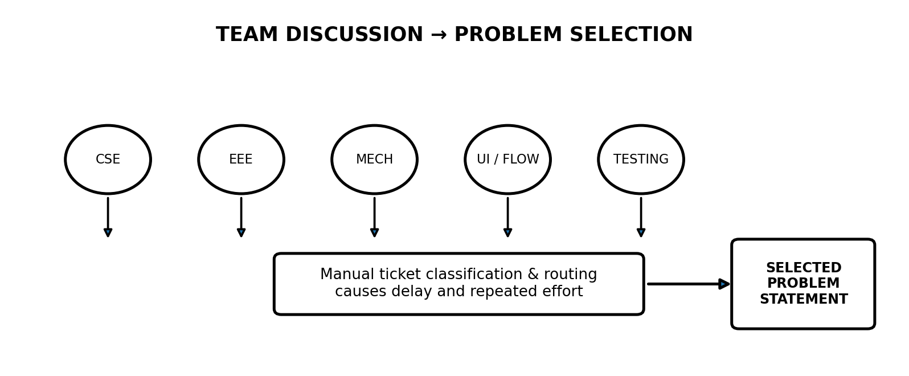
The team discussed the difficulties in handling a large number of support tickets manually. Tickets may be assigned to the wrong category or group, causing delays in resolution and requiring repeated manual effort.
Problem Statement:
To develop an automated ticket classification system using ServiceNow Flow Designer that can identify ticket details and automatically classify and route tickets to the appropriate category or assignment group, reducing manual effort and improving ticket-handling efficiency.
The team collaboratively discussed the required inputs, automation flow, classification conditions, assignment process, and possible exceptions.

Step 2: Brainstorm, Idea Listing and Grouping

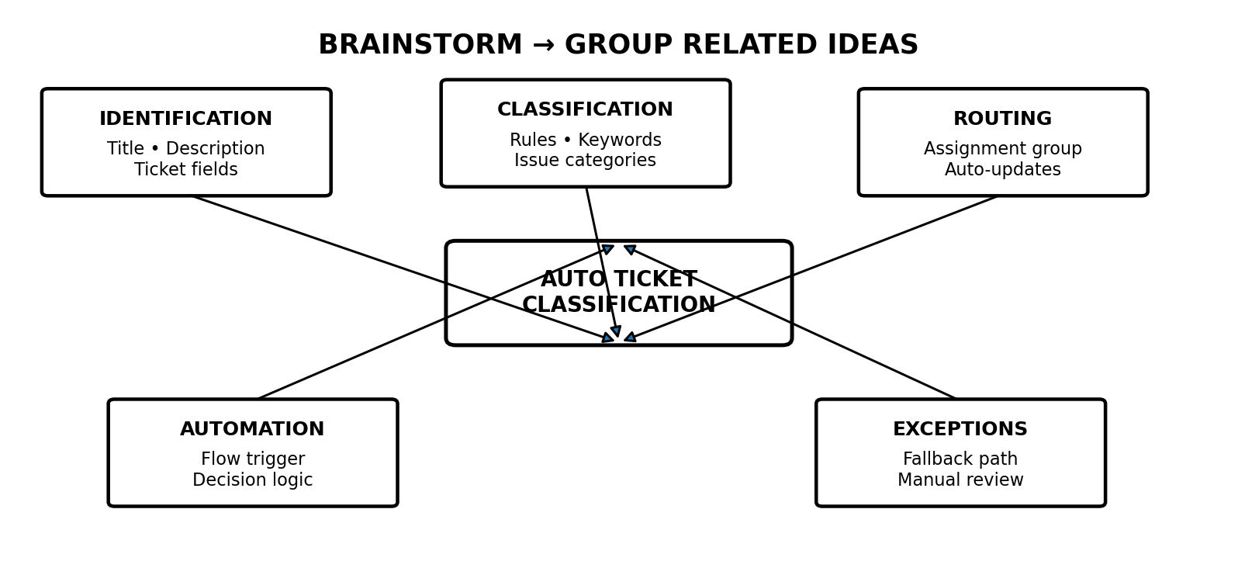

The team generated and discussed multiple ideas for automating ticket classification:
Ticket Identification - Analyze ticket title and description; identify keywords and relevant ticket information; capture important fields from incoming tickets.
Classification - Use predefined conditions and rules; map common keywords/issues to suitable categories; classify tickets based on issue type and available ticket fields.
Automatic Routing - Assign tickets to the appropriate assignment group; route tickets based on category; automatically update relevant ticket fields.
Automation and Workflow - Use ServiceNow Flow Designer to trigger the workflow automatically; create decision-based flows for different ticket types; reduce repeated manual work.
Exception Handling - Provide a fallback path for tickets that cannot be classified; send uncertain or unmatched tickets for manual review.
The ideas were grouped into five areas: Identification, Classification, Routing, Automation, and Exception Handling.

Step 3: Idea Prioritization
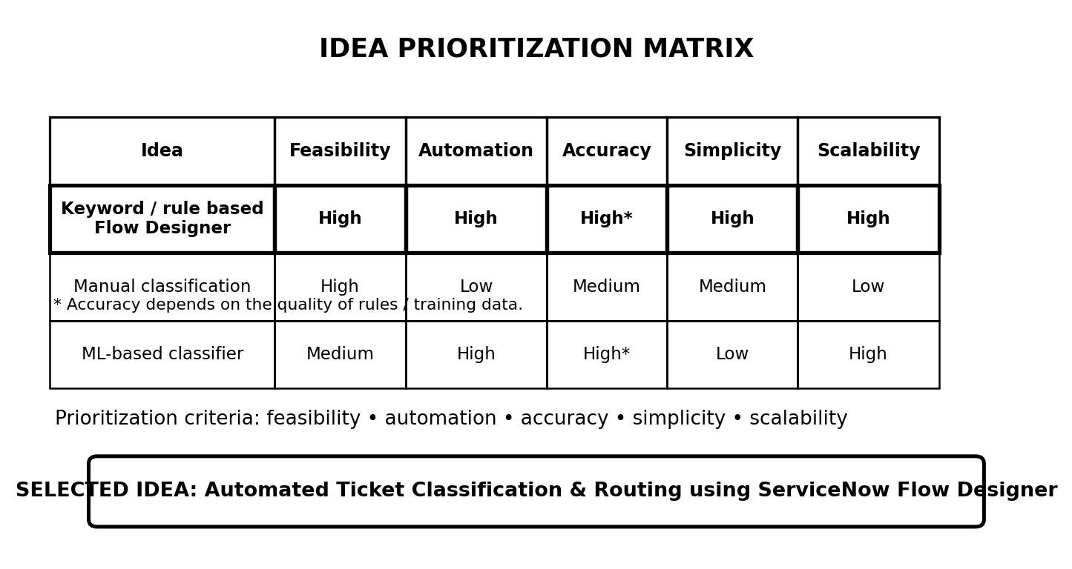

The generated ideas were evaluated based on:
The generated ideas were evaluated based on:
• Feasibility - Can the idea be implemented using the available tools and time?
• Automation - How much manual effort can it reduce?
• Accuracy - Can it classify and route tickets correctly?
• Implementation Simplicity - Can the team develop and test it effectively?
• Scalability - Can the approach handle different types of tickets?
Selected Idea:
Automated Ticket Classification and Routing using ServiceNow Flow Designer, with a manual-review path for unmatched tickets.

• Feasibility - Can the idea be implemented using the available tools and time?
• Automation - How much manual effort can it reduce?
• Accuracy - Can it classify and route tickets correctly?
• Implementation Simplicity - Can the team develop and test it effectively?
• Scalability - Can the approach handle different types of tickets?
Selected Idea:
Automated Ticket Classification and Routing using ServiceNow Flow Designer, with a manual-review path for unmatched tickets.

